Green Technology, Green Economy and Green Businesses: The Three Pillars Of A Worldwide Movement

An e-book for UN Summit 2019

originally a paper for BAASANA UK August 2019
Dr. Frank Owarish
September, 2019

Abstract
Compiled by Frank Owarish, Ph.D., CEO, International Institute for Strategic Research and Training; Member of the Royal Economic Society; former fellow in residence Queen Elizabeth House, Oxford University while also interacting with faculty members at Nuffield College

Introduction
Green technology encompasses a large-scale worldwide movement fostering the development of green economies in all countries. Bloomberg reports that green technology investment surpassed $1 trillion in 2004 and is projected to attract $10 trillion by 2050 (Henze, 2019; Kho, 2011). In reality, we have seen several businesses adopting green initiatives, and there exists multiple new green companies emerging. No specific policies foster the green movement, but this results from the growing consciousness of the need to transform existing economies in light of the severe deterioration of the global environment. The adoption of the Treaty of Paris on Climate Change is an impetus in this movement and the sustainable development goals adopted by the United Nations.
This e-book looks at case studies of the efforts going on, considering the stakeholders involved in the agricultural, manufacturing, and service sectors. Governmental organizations play a defining role in context. The purpose of non-governmental organizations is quite significant, and international organizations often play a spearheading role. With technology is a driving force, we have to contrast the rate of deterioration of the environment with that of transformation to a green economy. For several decades the former was higher than the latter, but now it looks like some catching up is happening, perhaps more so with significant players getting involved.
The Economy: A Paradigm Shift

The economy consists traditionally of three sectors: agricultural, industrial, and service. All three areas have been benefitting from the information revolution and now stand to be impacted by green technologies. According to the (United Nations) UN Environment Program, "A green economy is defined as low carbon, resource-efficient and socially inclusive." In a green economy, growth in employment and income are driven by public and private investment into economic activities, infrastructure. Also, assets that allow reduced carbon emissions and pollution enhanced energy and resource efficiency, and prevention of the loss of biodiversity and ecosystem services." (United Nations, 2019).
The UN Environment Program states that "The role of Green Economy, Sustainable Consumption and Production and Resource Efficiency for Sustainable Development: Sustainable Consumption and Production aims to improve production processes and consumption practices to reduce resource consumption, waste generation and emissions across the full life cycle of processes and products – while Resource Efficiency refers to the ways in which resources are used to deliver value to society and aims to reduce the amount of resources needed, and emissions and waste generated, per unit of product or service. The Green Economy provides a macro-economic approach to sustainable economic growth with a central focus on investments, employment and skills."
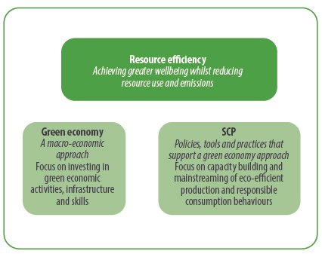
Source: UN Green Economy, (2019)

Review of the Foundations
In the published issue “A Guidebook to the Green Economy” United Nations played a crucial role in context in fostering the movement. The details can be found in the Issue 1: https://sustainabledevelopment.un.org/content/documents/GE%20Guidebook.pdf
Additionally, there is evidence of the green economy in the interrelationships with South Africa.
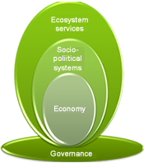
Source: Department of Environmental Affairs (2019)
South Africa views the green economy as a sustainable de­velopment path based on addressing the interdependence between economic growth, social protection, and natural ecosystem. The South African approach is to ensure that practical and implementable action plans support green economy programs. Calling for South Africa to build on existing best processes, programs, initiatives and indigenous knowledge in key sectors "Towards a resource-efficient, low carbon and pre-employment growth path." In reality, a solo government cannot manage to fund a just transition to a green economy without private sector and civil society playing a fundamental role.
The country's sustainable development vision is outlined in the National Framework for Sustainable Development (2008). "South Africa aspires to be a sustainable, economically prosperous and self-reliant national state that safeguards its democracy by meeting the fundamental human needs of its people. Also, essential efforts include responsible management of limited ecological resources, advancing efficient and effective integrated planning and governance through national, regional, and global collaboration".
A more formal definition can be regarded as a “system of economic activities related to the production, distribution, and consumption of goods and services that result in improved well-being over the long term without exposing future generations to significant environmental risks or ecological scarcities”. It implies the decoupling of resource use and environmental impacts from economic growth. This is characterized by a substantial increase of investment in green sectors that are supported by enabling policy reforms. The Green Economy refers to two inter-linked developmental outcomes for the South African economy:
- Growing economic activity (which leads to investment, jobs, and competitiveness) in the green industry sector
- A shift in the economy towards cleaner industries and sectors.
South Africa recognizes that green economy action has several crosscutting roles and responsibilities. The implementation is significantly decentralized and includes the private sector, civil society and all levels of government. The nine key focus areas are identified in the green economy programs that include:
- Green buildings and the built environment: program includes greening private and public buildings
- Sustainable transport and infrastructure: program includes promoting non-motorised transport
- Clean energy and energy efficiency: program comprise -
  - Expanding off-grid options in rural and urban
  - REFIT optimization for large scale renewable and localization and
  - Up-scaling Solar Water Heater rollout
- Resource conservation and management: programs include -
  - National payments for ecosystem services
  - Up-scale “Working for” programs
  - Infrastructure resilience and ecosystems
  - Offset program
  - Wildlife management
- Sustainable waste management practices: program comprises -
  - Waste beneficiation
  - Zero waste community program for 500 000 households
- Agriculture, food production and forestry: program includes integrated sustainable agricultural production
- Water management: program comprises -
  - Water harvesting
  - An alternative technology for effluent management
  - Comprehensive municipal water metering (Demand-side management)
  - Reduce water losses in agriculture, municipalities, and mining
- Sustainable consumption and production: program include -
  - Industry-specific production methods
  - Industrial production technology changes
- Environmental sustainability: program comprises -
  - Greening significant events and legacy (2010 Soccer World Cup, COP17 flagship & Tourism) and
  - Research, awareness and skills development, and knowledge management.
The overall enablers of implementation for the green economy programs identified include regulatory framework; market-based instruments; innovation; science; and technology commercialization. Additionally, more significant localization; manufacturing; investment, finance opportunities, and financing instruments include leveraging of funds; availability of skills; institutional capabilities and capacity and partnerships.
Several initiatives within civil society, private and private sectors are already in implementation. The investment potential within the country is significant to position South Africa as a primary investor in funding a transition towards a greener economy. For example, the following commitments: DEA R800 million, DBSA R10 billion, IDC R25 billion over five years and private finance estimated at R100 billion. In 2009 South Africa received a significant boost in its ambition to meet clean energy goals. The $500 million for South Africa’s Clean Technology Fund (CTF) Investment Plan (IP) paves the way for us to move closer to our vision of generating electricity from renewable energy, improving energy efficiency, and providing 1 million households with solar water heating over the next five years (Department of Environmental Affairs, 2019).
Case Study Provided by The European Environment Agency:
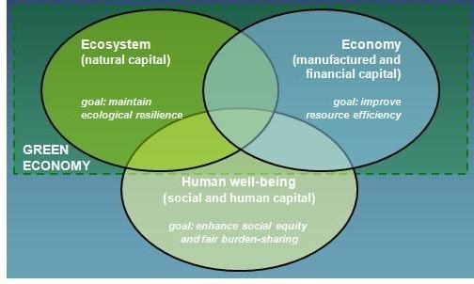
Source: European Environmental Agency (2014)

The European Environment Agency (EEA) is an agency of the European Union, whose task is to provide sound, independent information on the environment. The EEA aims to support sustainable development by helping to achieve significant and measurable improvement in Europe's environment, through the provision of timely, targeted, relevant, and reliable information to policymaking agents and the public. An assessment states that "the economic and technological changes leading towards green economy objectives across the EU economy are proceeding too slowly; what is required is a much bigger, deeper, and more permanent change in the EU economy and society to create both new opportunities and substitution processes across the economic structure. Thus, it's important to study and understand enabling factors and mechanisms at the crossroads of policies and real economy dynamics that could accelerate and direct the transformation." (European Environmental Agency, 2014).

Watch our latest videos about Europe's environment on the EEA's YouTube channel

Source: https://www.youtube.com/watch?time_continue=44&v=_9mHi93n2AI

Or

https://www.bing.com/videos/search?q=european+environmental+agency+videos&view=detail&mid=F5A2881F5ABFF377E444F5A2881F5ABFF377E444&FORM=VIRE

India As A Case in Point
India is one of the fastest-growing economies in the world but faces an enormous challenge: how can it fulfill the basic needs of its population without overshooting environmental limits? Although millions of Indians have been lifted out of poverty in recent decades, gross inequalities between rich and poor have also become increasingly entrenched. India is the world’s 12th most unequal society, with the wealthiest 1% of Indians owning almost 60% of the nation’s wealth. India increasingly faces a jobs shortfall as shifting global markets and technologies restrict employment opportunities – making escaping poverty even harder.
Although India has made significant international commitments towards the 2030 Global Development Agenda and the Paris Climate Agreement, it still ranks 68th out of 80 countries on the Global Green Economy Index (GGEI). Much work remains to be done. The Green Economy Barometer provides insights into the achievements of the Indian economy across high impact sectors and hence is indispensable in developing the next 15-year plan by the Government of India.

The 2018 Green Economy Barometer
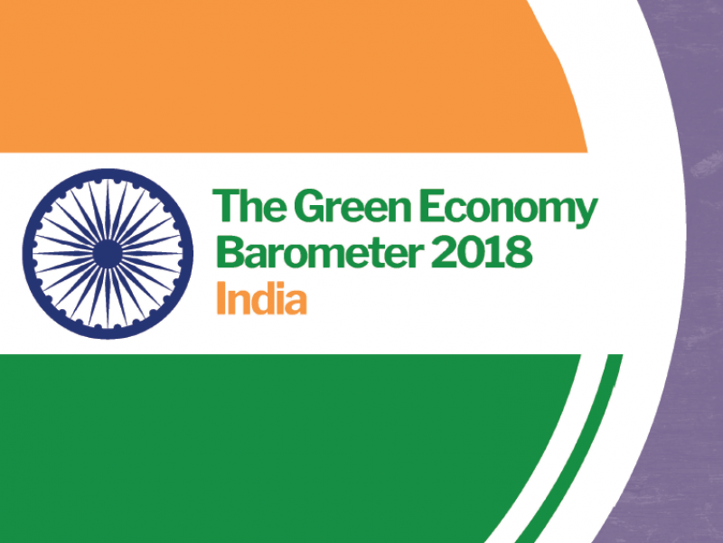
Source: Green Economy Coalition (2018)
Part of a series assessing the green economies of our seven partner nations, The India Green Economy Barometer tracks the economy on five aspects:
- Measuring what matters analyses the resilience of India’s economic modeling and measurement. It discusses alternatives to the purely financial terms of measuring - the GDP and the fiscal deficit, such as Gross National Happiness, the Happy Planet Index and Social Progress Index. India ranked 6th out of 190 countries listed by GDP growth in 2017, while in the same year, India was ranked 122 out of 155th countries in Gross National Happiness report.
- Greening High Impact Sectors- Key sectors with a high potential to progress towards greening are identified, these are - Agriculture, Renewable Energy, Construction, Transport, and Medium and Small Industries. The contribution of MSME towards the GDP is high 37% in 2012-13, and it has the potential to provide millions of new jobs.
- Investing in People assesses the condition of people and the action taken by the government to enhance and develop human resources. In 2013 the GOI made it compulsory for the companies to spend 2% of their profits on corporate social responsibility.
- Managing Natural Systems emphasizes the protection of India’s natural capital – both valuable but finite raw materials, and the harder to measure but irreplaceable assets like biodiversity, rare species, and clean air and water. It examines how more can be done to ensure the equitable distribution of resources and promoting resilience for production and consumption.
- Influencing Financial Flows- the trend and quantum of green investment in the economy, along with the government’s spending on the green economy is analyzed, and the inclusiveness of the financial sector is assessed. The government has taken the initiative to manage the resources better by introducing new coal taxes, through which a total collection of INR 170 billion collected till 2014-15. Renewable energy meanwhile has attracted remarkable investment of USS 11.4 billion (Green Economy Coalition, 2018).
Green New Deal in the US
An outline of basic thoughts: “The Green New Deal we are proposing will be similar in scale to the mobilization efforts seen in World War II or the Marshall Plan. Half measures will not work The time for slow and incremental efforts has long past [sic].” – Alexandria Ocasio-Cortez, then-candidate for the U.S. House of Representatives, Huffington Post, June 26, 2018
“Just transitioning 10% of agricultural production to best-practice regenerative systems will sequester enough CO2 to reverse climate change and restore the global climate. Regenerative Agriculture can change agriculture from being a major contributor to climate change to becoming a major solution.” – Andre Leu, international director, Regeneration International, “Reversing Climate Change with Regenerative Agriculture,” October 9, 2018
Ronnie Cummins outlines vital aspects of the movement from the Great Climate Awakening to The Green New Deal with an underlying question of a possibility for the US to achieve zero-emission 2030 (Cummins, 2019).
The World Bank and green growth
“Green Growth” is a relatively new and still somewhat amorphous concept. It can be understood in very general terms as balancing investments emphasizing nearer-term income growth to reduce poverty and expenditures in sustaining longer-term environmental wealth. Some proponents of Green Growth go further to emphasize the potential for strategically crafted environmental investments and policies to achieve sustainability at low cost, perhaps even to help stimulate nearer-term growth. Standard economic theory on growth and environmental sustainability does not provide assurance of substantial positive spillovers from environmental policies to income growth, and it shows that the “greenness” of an economically efficient growth path can depend substantially on the starting point for the economy. Factor-augmenting technical-change targeting at offsetting resource depletion is critical to sustaining long-term growth within natural limits on the availability of natural resources and environmental services. Some plausible channels are indicating a potential for more synergy between economic growth and environmental sustainability than implied by standard economic theory. These include spillover effects from ecological measures on the productivity of other productive factors, correction of pre-existing economic distortions, and economy-wide “coordination failures” that can be linked to environmental sustainability. However, there is not enough empirical evidence yet available to confidently address their practical significance. Consequently, some claims of substantial win-win opportunities between growth and the environment may need to be tempered (The World Bank, 2018).
The OECD Approach
The OECD held its 2018 Green Growth and Sustainable Development (GGSD) Forum on the theme of “Inclusive solutions for the green transition: Competitiveness, jobs/skills, and social dimensions.” It was held in conjunction with the Annual Conference of the Green Growth Knowledge Platform (GGKP), the global partnership established by the OECD, Global Green Growth Institute (GGGI), UN Environment and the World Bank. The conference addressed the political economy of green and low-carbon policy reforms, identified their distributional impacts, and explored inclusive solutions for households. Additionally, workers, sectors, and regions that may otherwise be struck by the transition were addressed to help them contribute to a greener future. The Forum sessions were developed around competitiveness, employment, and distributional impacts of green policies.
Global momentum toward sustainable development has been renewed by the success of the 2030 Sustainable Development Agenda and Paris Agreement on climate change. The latest findings by the UN Intergovernmental Panel on Climate Change (IPCC) warn that current efforts to tackle rising temperatures are dangerously off track, while a growing body of evidence shows that accelerating climate action can bring strong, sustainable and inclusive growth. OECD work indicates that if we combine growth-enhancing policies and climate action, global GDP in 2050 could be nearly 5% higher boost in investment and avoid climate damage. Recent work by New Climate Economy and ILO suggest that bold climate action could yield direct economic gains.

Why a forum on the green transition?
The Forum is aimed at creating a new narrative around green growth and national competitiveness and examining examples of “transition management strategies” towards green and inclusive growth. It will consist of panel discussions among policy makers, business, labor and civil society representatives and academia, as well as presentations of latest research and evidence base contributed by the OECD, other GGKP partners and beyond.
Source: Organization for Economic Cooperation and Development (OECD) (2018)
Green businesses
Green business refers to a sustainable business that has no negative impact on the global or local environment, community, society, or economy. A green company meets the triple bottom line, i.e., people, profit, and the planet. They are backed with progressive environmental and human rights policies.
Green business advocacy
Best illustrated by Green America (2017): “Our mission is to harness economic power—the strength of consumers, investors, businesses, and the marketplace—to create a socially just and environmentally sustainable society.”
Further, Green Business= triple bottom line company. Mission-based business. A social enterprise & social entrepreneurship. Socially responsible investing & impact investing. Green America also operates a green business network.

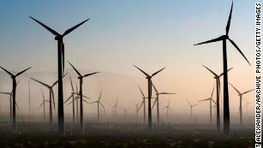
Source: Green America (2017)
America's renewable energy capacity is now greater than coal By agreeing to buy power from an under-construction Texas solar farm, the maker of Cadbury chocolate and Ritz crackers expect to slash 80,000 metric tons of carbon dioxide emissions — or roughly 5% of the company's 2013 global manufacturing emissions. The renewable energy purchase reflects Mondelez's desire to protect its agriculture supply chain from the threat of climate change; the company told CNN Business (Boston News, 2019).
Businesses going green
If you believe the global push to going green is driven entirely by concerned citizens, politicians, and non-profit organizations, it's time to rethink! Recently several leading companies have walked their way to eco-friendly and sustainable business practices. We have listed down some of them, who adopted "green" so successfully that sustainability is now an essential part of their business operations! Have a look here.
1. McDonald's
Giving in to the increasing public shift towards green living, McDonald's smartly embraced green business practices. Instead of ravaging the natural habitat of animals, McDonald's collaborated with PETA to carry out its business practices systematically. Likewise, in 2012, the company ultimately got rid of the foam coffee cups by switching to double-walled paper containers, which are 100 percent recyclable.
The next plan is to install distinct trash containers for cycling and composting. It is yet to see how much fast-food chain follows the same route.
Source: McDonalds.com (2019)
2. DuPont
DuPont is one of those companies which have been effectively taking a stride towards sustainable operations. In addition to lowering its emission of greenhouse gases, DuPont appointed ex-Greenpeace head as an adviser to the board. The company remained true to its word and efficiently reduced greenhouse gas emission by 63%-which is far beyond the timetable set in the Kyoto protocol.
Source: Dupont.com (2019)
3. Home Depot
It took some time to home depot to turn things around in terms of sustainable business operations. After the company was identified as the world’s largest retailer of old wood products, protests and demonstrations broke at home depot stores. When the outcry spread further, home depot decided to act and rolled out a new “no old-growth sales” policy. This policy promised an end to harvesting trees from old-growth rainforests.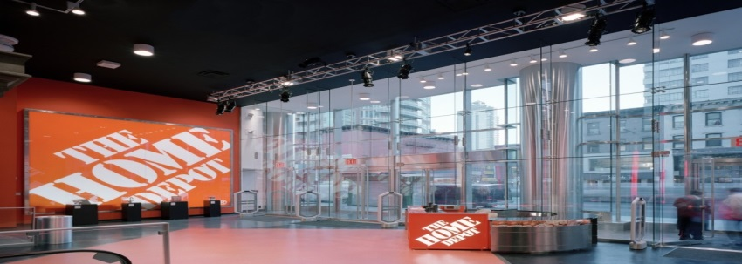
Source: Homedepot.com (2019)
4. Coca Cola
Coca cola narrowed down three environmental goals to direct their effort to green business practices- sustainable packaging, water stewardship, and climate & energy protection. Working on these goals, Coca-Cola has involved itself in the recycling program and came up with a sustainable packaging design in just a few years.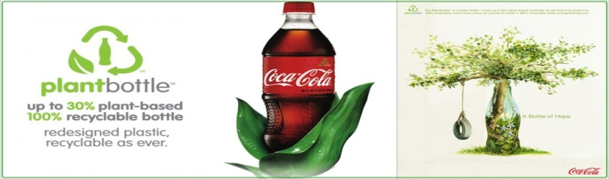
Source: Cocacola.com (2019)
5. Wal-Mart
Walmart was possibly the most hated name in the entire green change, but not anymore. The store launched an ambitious long-term plan to power its stores using 100% renewable energy sources. Walmart uses its waste, eliminating corporate philosophy to turn its operations eco-friendlier than ever.
Source: Walmart.com (2019)
6. Dell
Electronic equipment are obviously most difficult products to safely dispose of. Luckily, one of the foremost leaders in this filed stepped forward to make the task less unnerving. Dell launched “no computer should go to waste” recycling program which allowed customers to return dell branded products to the company for free. Dell has also established programs which accept monitors, printers, and computers from other companies for safe disposal!
Source: Dell.com (2019)
7. Brooks
Brooks joined the “green gang” by rolling out a biodegradable running shoe. The decomposition does not start until this shoe is stored in an active enclosed landfill. Besides, these shoes take just 30 years to biodegrade instead of 1000 years made by traditional ethylene-vinyl acetate soles. The best thing is, Brooks expects to save up to 30 million pounds of landfill waste over those same 20 years!
Source: Brooks (2019)
8. Honda
Honda has gone way beyond its environmental duties that it is now called “the most fuel-efficient auto company in the US.” The leading green successes have been hydrogen fuel cell powers FCX, an entirely hydrogen-based infrastructure, and reduction in carbon dioxide emission by 5% so far. Calling it the most well-heeled green advocate will not be wrong!
Source: Honda.com (2019)
9. Target
Target takes sustainable functions right to its store shelves. The company launched its eco clothing line at Barney’s New York, which is said to have been created using dynamic fabrics. The clothing line is available at Target locations and earned quite some acclaim from the sustainability movement critics.
Source: Target.com (2019)
10. SC Johnson
SC Johnson has been trying to lessen the impact of its products through the use of a green list process (the system which ranks the environmental effect by evaluating raw materials used). The company let go off 1.8 million pounds of polyvinylidene chloride eliminated from Saran Wrap. In addition to that, it has also scaled back its coal-fired plants with natural gas and methane-powered facilities.

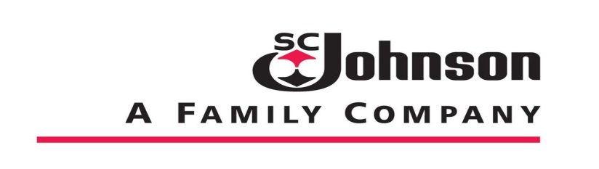
Source: SCJohnson.com (2019)
The list does not end here, as this is only the beginning of a green corporate revolution. The sustainable business orientation has been gradually growing, but it is going to become a reality for organizations in no time (Humming International, 2019). Let us know of any organization which you believe is the green corporate wizard.
The Automobile Industry Has Been Doing Its Fair Share of Transformation
Great momentum is being accomplished as described in Conserve Energy Future (2019); the 17 top companies that are going green in 2019. ASUA, Japan, in cooperation with WAFUNIF, organized two world conferences at the UN headquarters, one in 2014 and the other in 2016. Both meetings brought the representatives of the leading automobile manufacturing companies which provided clear and convincing information of the efforts which were being made in transforming cars, buses, and trucks to eco-friendly technologies.
Strategic Automotive Technologies: The Eco-Friendly Revolution
ASUA Activities on EcoDrive
Changing the existing fleet of transportation systems to hybrid, electrical, and other eco-friendly technologies will take time. ASUA feels that its eco-drive approach is a good transition strategy.
ASUA has been promoting eco-drive with a high degree of success in Japan with concrete empirical evidence (Owarish, 2015).
ASUA specializes in promoting EcoDrive for the past two decades providing consulting services for major manufacturers and significant logistics companies. Also, it is a trustee of business from the Ministry of Economy, trade, and industry, Ministry of Land, Infrastructure, Transport and Tourism, and the Ministry of Environment. ASUA actively lectures on EcoDrive throughout Japan (Owarish, 2015).
EcoDrive' is a method of environmentally-friendly driving to reduce emission gas which increases CO2 emission and causes air pollution. Specifically, it can be based on driver's manner, including restraining from idling while standing, accelerating quickly, and hitting the brakes. Studies and Analyses conducted in collaboration with academic institutions (Waseda Univ. and Shibaura Inst. of Technology) show that practicing this driving method brings various positive outcomes such as fuel reduction, traﬃc accident decrease, and driving manner improvement. Its paper was published at Society of Automotive Engineers of Japan in 2006 whose outcome gathered attention (Owarish, 2015).
Promoting EcoDrive requires us to continue providing information to drivers by visualizing vehicular information without restricting to simple promotion activity. For that purpose, we developed a system to evaluate the relationship between how they drive and their fuel consumption and patented it's in Tokyo. Furthermore, we have been developing an EcoDrive message utilizing the automobile's probe data. Also, we operate an EcoDrive promoting program by using a fuel eﬃciency management system called ReCoo and obtained many more actual fuel consumption data. As for overseas, we have been promoting EcoDrive utilizing real fuel consumption data of private automobiles purchased in Europe. In 2012, ASUA was authorized by WAFUNIF and approved to operate EcoDrive conference at the United Nations Headquarters (Owarish, 2015).
EcoDrive, a proposed method to improve fuel eﬃciency and reduce CO2, leads us all to act in a better way considering others and to be more human by enhancing the value of our humanity. ASUA, with the achievements in Japan, plans to promote EcoDrive activity towards the world. For instance, we aim EcoDrive to be recognized globally regardless of borders and diﬀerences of cultures and economic environment by certifying streets which EcoDrive is actively practiced as 'EcoDrive Way' and holding 'EcoDrive Challenge Contest' targeting taxi drivers in major cities around the world. ASUA stated the eﬀect of EcoDrive and its possibility in the International Conference on Global Environment, Carbon Reduction and EcoDrive held at the United Nations Headquarters in New York on October 17th, 2014 (Owarish, 2015).
We have discussed to create EcoDrive Charter in 'Conference in Nagoya in October 2015 as a part of 10th memorial event of 'Aichi World Expo' in Japan and also 'Paris conference' as a side event of COP21 in Paris in November. We have presented "EcoDrive Declaration" the International Conference on Global Environment, Carbon Reduction and EcoDrive held at the United Nations Headquarters in New York on November 19th, 2016. Eco-Drive declaration is an Eco-Drive textbook that is translated into 7 languages. This textbook shows not only how to drive, but attitude change also. As it is written in the SDGs Sustainable Development Goals Agenda 2030, and was announced in COP 21 in Paris, "not only the regulations or technical development are important, but the change of lifestyle is equally important as well".
In our opinion, the start of doing Eco-Drive will change our mind (Owarish, 2015). Eco-Drive can work together to make this world a better place for drivers, passengers, and for all.

Conclusion
According to the Financial Times, going green is good for business as elaborated in
https://www.ft.com/content/b45860b2-917e-11e7-a9e6-11d2f0ebb7f0

References
Boston News (2019). Retrieved from https://whdh.com/news/company-planning-to-produce-oreo-cookies-using-solar-power/
Conserve Energy Future (2019). 17 Top Companies that are going green in 2019. Retrieved from https://www.conserve-energy-future.com/top-companies-that-are-going-green.php
Cummins, R. (2019). Why the food and regeneration movement should support a green new deal. Retrieved from https://regenerationinternational.org
Department of Environmental Affairs (2019). About green economy. Retrieved from https://www.environment.gov.za/projectsprogrammes/greeneconomy/about
European Environmental Agency, 2014. Resource-efficient green economy and EU policies. Retrieved from https://www.eea.europa.eu/publications/resourceefficient-green-economy-and-eu
Financial Times (2019). Retrieved from
Green America (2017). Green American magazine. Retrieved from https://www.greenamerica.org/
Green Economy Coalition (2018. India Green Economy Barometer 2014 full report. Retrieved from https://www.greeneconomycoalition.org/assets/reports/Barometers-2018/India-Barometer-2018-Full-November-Draft.pdf
Green Economy Coalition, 2018. The 2018 Green Economy Barometer. Retrieved from https://www.greeneconomycoalition.org
Heneze, V. (2019). Solar, wind, batteries to attract $10 trillion to 2015, but curbing emissions long-term will require other technologies too. Retrieved from Bloomberg.com
https://www.ft.com/content/b45860b2-917e-11e7-a9e6-11d2f0ebb7f0
Humming International (2019). 10 Leading Companies That Efficiently Went “Green” Retrieved from http://hummingbirdinternational.net/10-companies-that-efficiently-went-green/
Kho, J. (2011). Global clean energy surpass $1 trillion. Retrieved from Forbes.com
Organization for Economic Cooperation and Development (OECD) (2018). Inclusive solutions for the green transition. Retrieved from https://www.oecd.org/greengrowth/ggsd-2018/
Owarish, F., (2015). Strategic Automotive Technologies: The Eco-Friendly Revolution. Retrieved from https://www.g-casa.com/conferences/prague15/pdf_paper/Owarish.pdf
The World Bank (2018). The conceptual basis and operational implications of "Green Growth". Retrieved from https://www.worldbank.org/en/events/2018/11/07/the-conceptual-basis-and-operational-implications-of-green-growth
United Nations (UN), 2019. Green Economy. Retrieved from https://www.unenvironment.org/regions/asia-and-pacific/regional-initiatives/supporting-resource-efficiency/green-economy

